**Practical 3 : Write a shell script to display multiplication table of given number.**

echo "My name is Harsh Vadgama"

echo "My enrollment number is 92410103123"

echo "My class is EC5-C"

echo "Enter a number to display its multiplication table:"

read n

if ! [[ "$n" =~ ^[0-9]+$ ]]; then

echo "Invalid input!!"

exit 1

fi

echo "Multiplication table for $n:"

for ((i = 1; i <= 10; i++)); do

echo "$n x $i = $((n * i))"

done

output :

My name is Harsh Vadgama

My enrollment number is 92410103123

My class is EC5-C

Enter a number to display its multiplication table:

5

Multiplication table for 5:

5 x 1 = 5

5 x 2 = 10

5 x 3 = 15

5 x 4 = 20

5 x 5 = 25

5 x 6 = 30

5 x 7 = 35

5 x 8 = 40

5 x 9 = 45

5 x 10 = 50

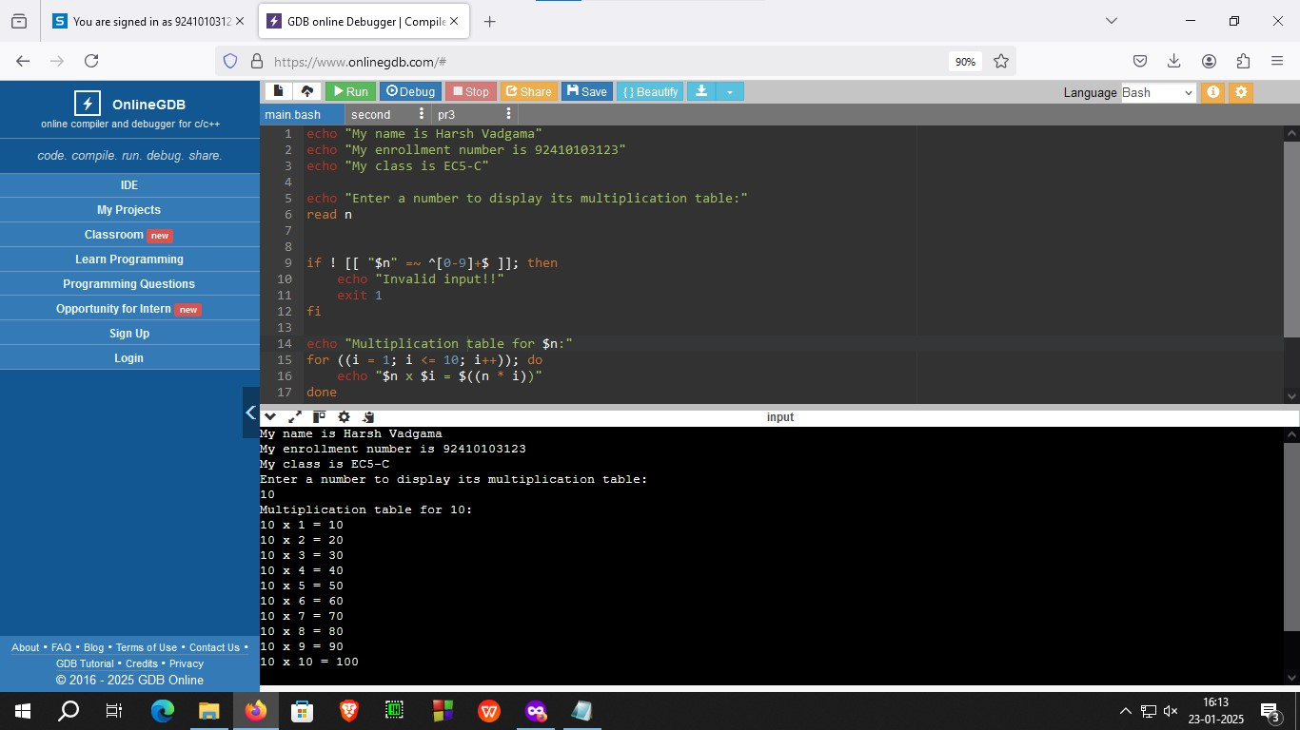

Figure 3.1 : program to print table of given number